1. File attached to submission

2. Screenshots of Packet Tracer Model
A. Network Topology
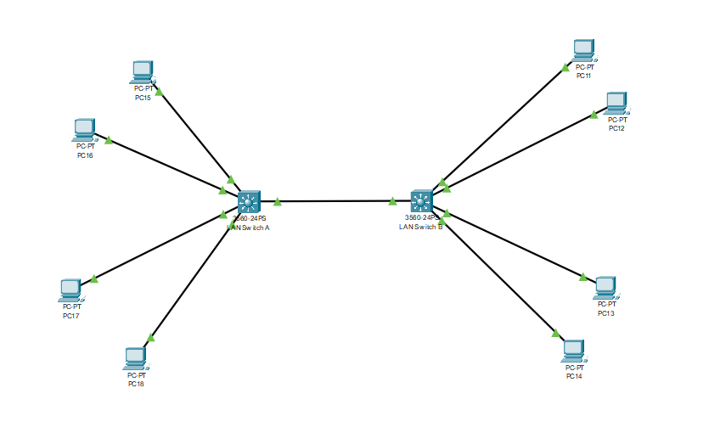
B. Successful Ping from PC to PC
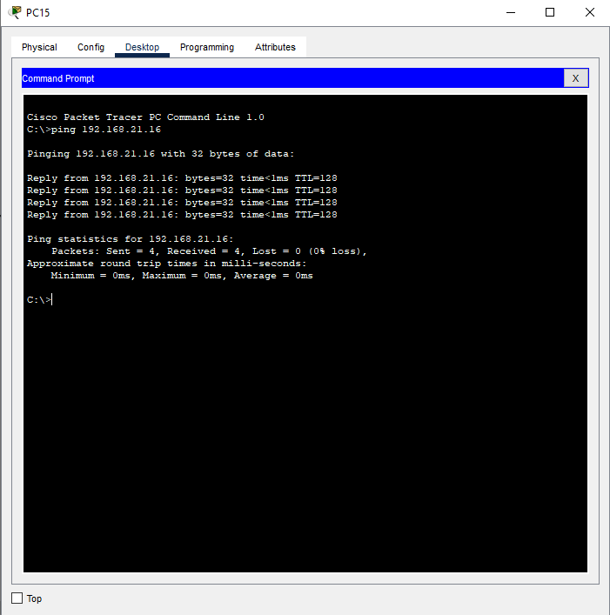
C. Unsuccessful Ping from PC to PC
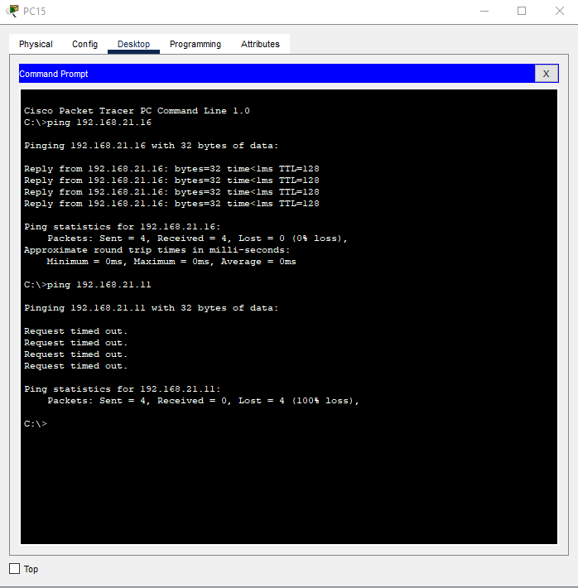
3. Photos of Switch/PC Configuration
A. #show ip interface
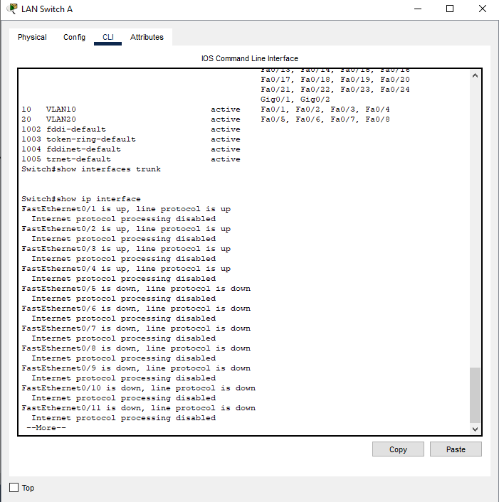
- #show vlan
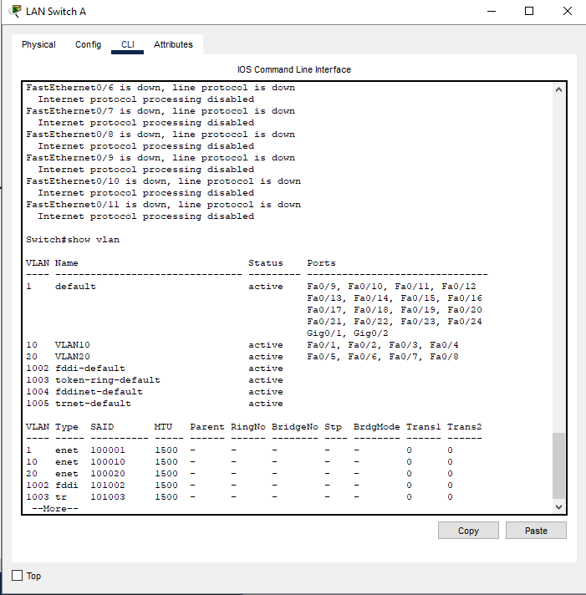
- Lab Computer IPv4 Interface Configuration
  - PC11
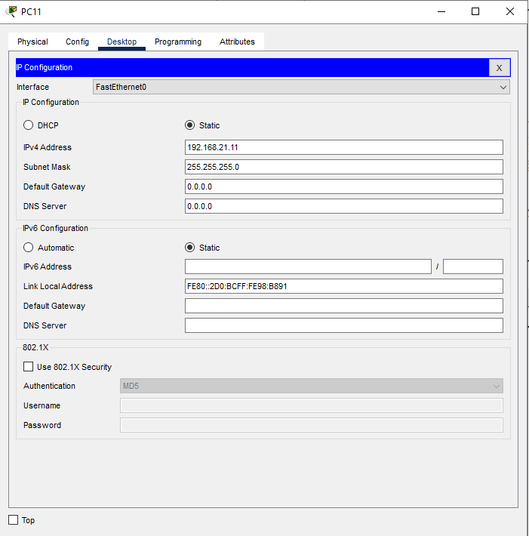
  - PC12
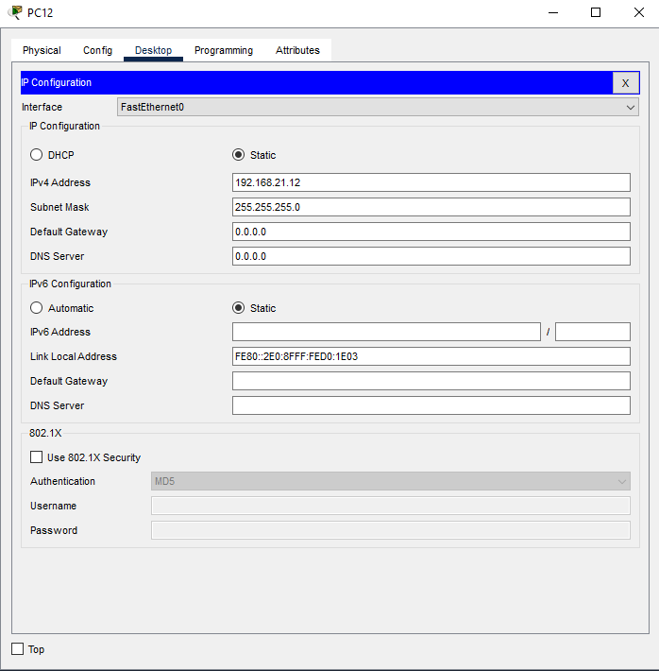

  - PC13
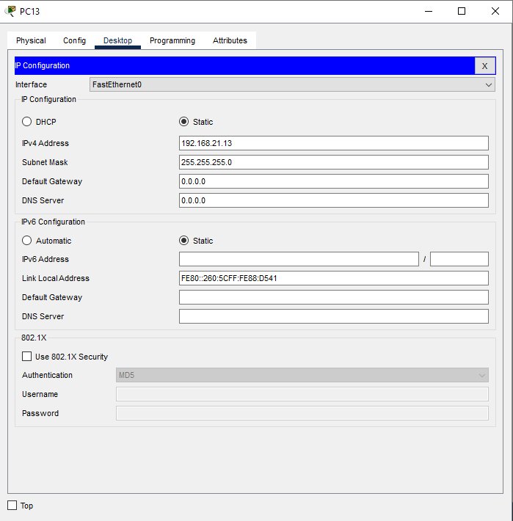
  - PC14
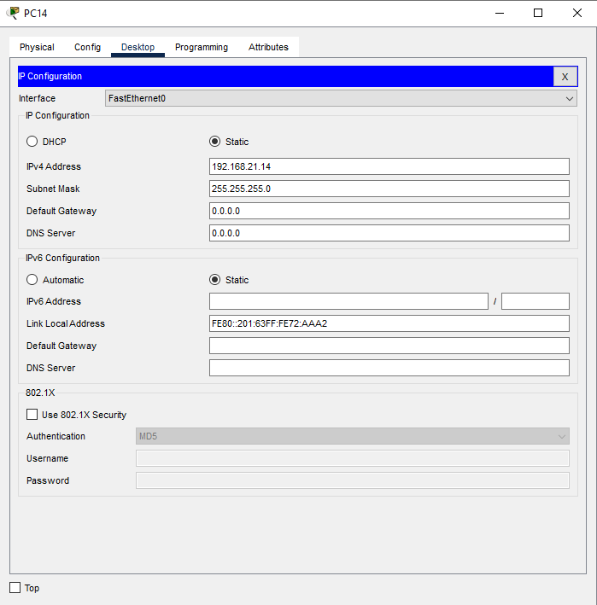

  - PC15
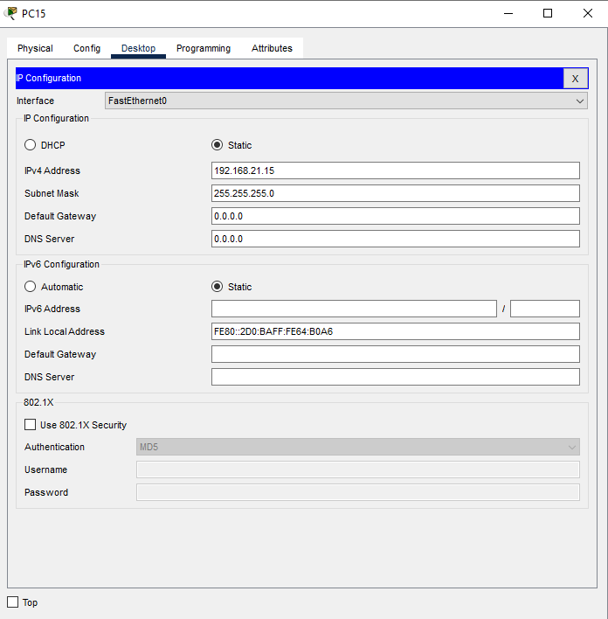
  - PC16
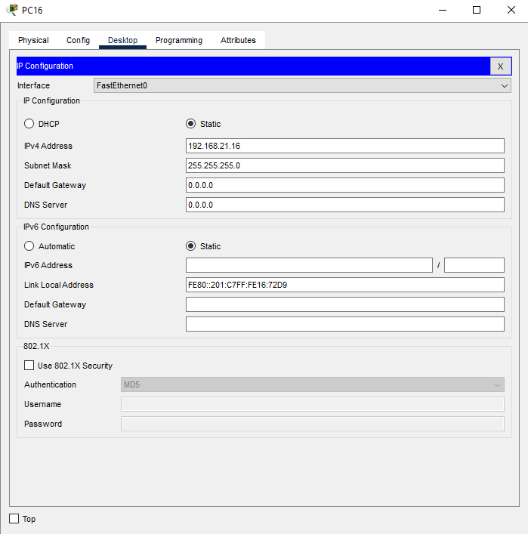

  - PC17
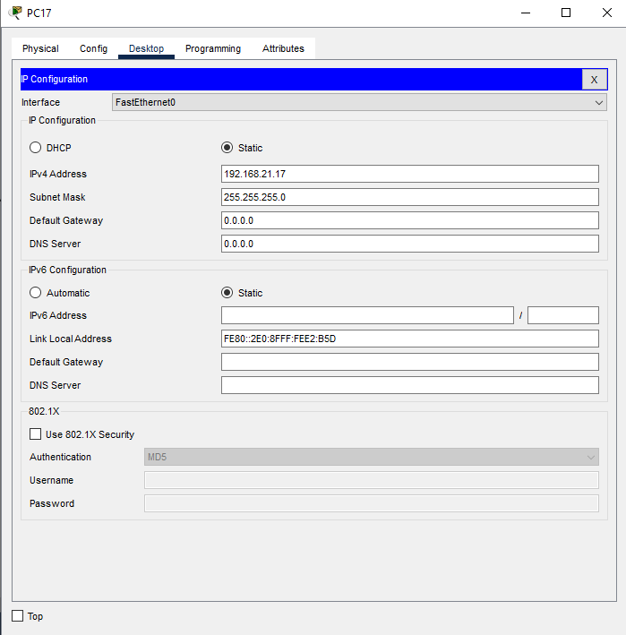
  - PC18
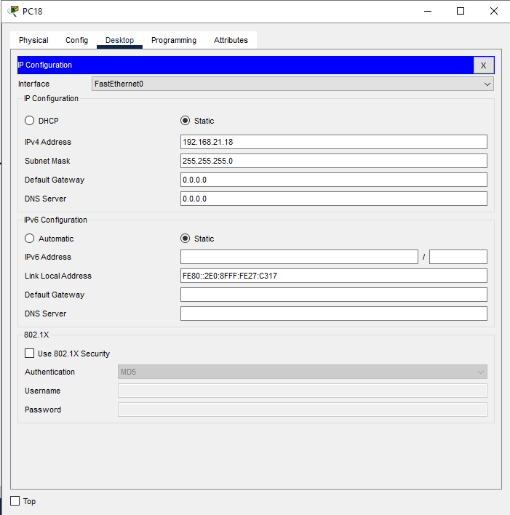

- Lab Computer ICMP Results (Successful ICMP packets being sent and received)
  - PC11
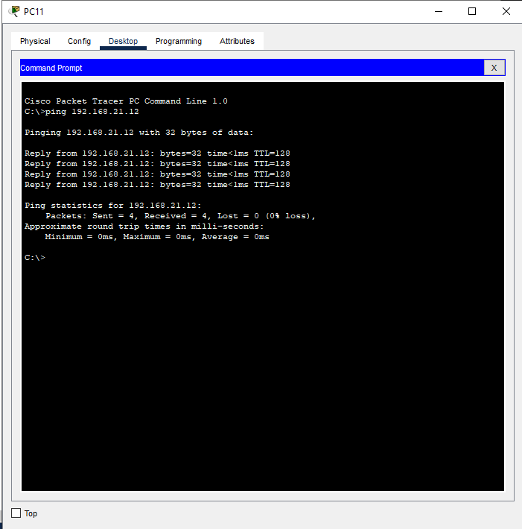
  - PC12
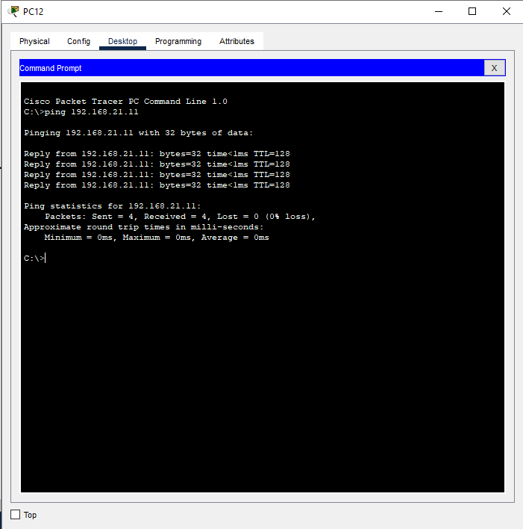

  - PC13
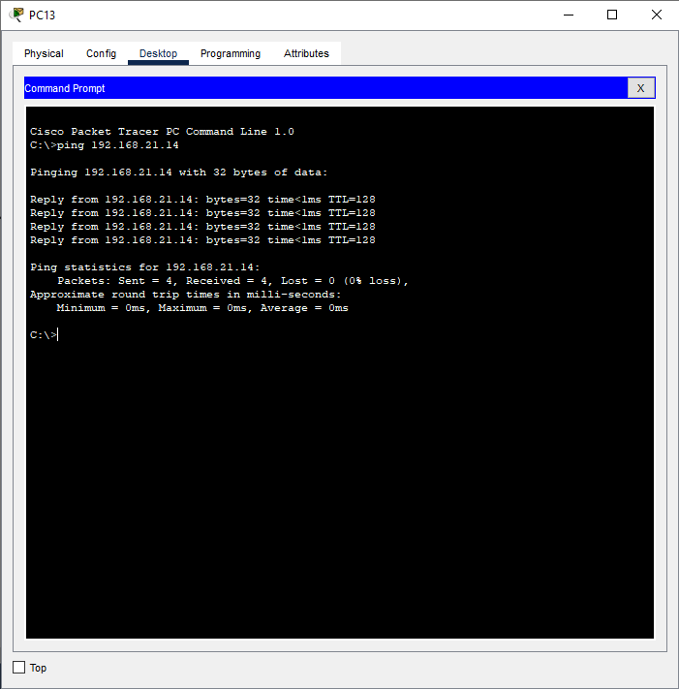
  - PC14
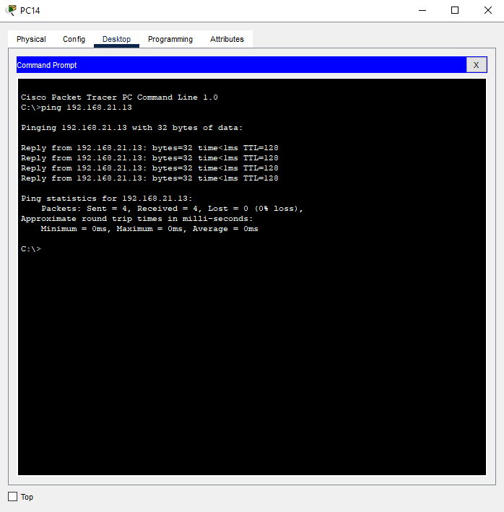

  - PC15
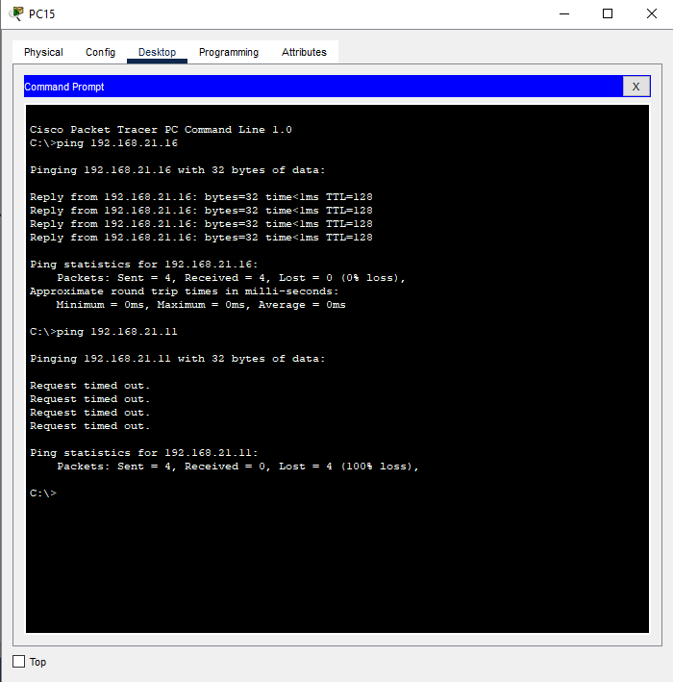
  - PC16
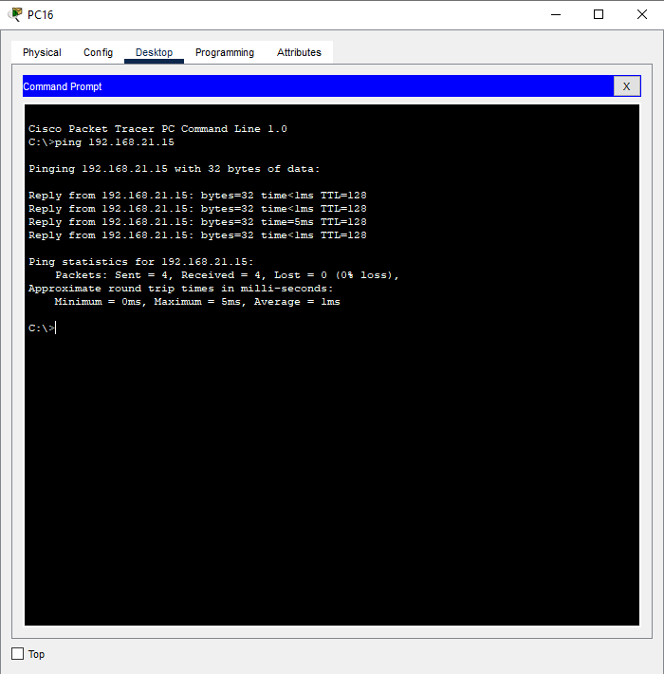

  - PC17
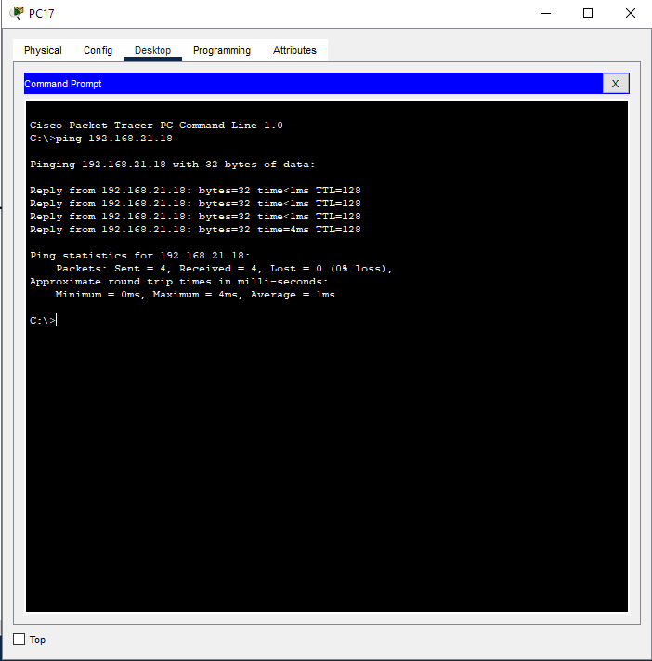
  - PC18
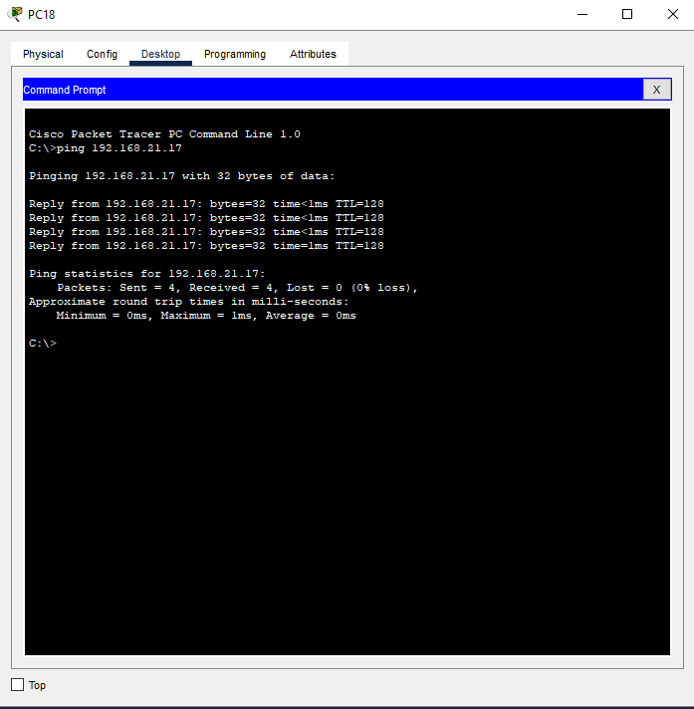
4. Lab 4 Questions
1. What VLAN number value is assigned to the default VLAN?
By default, all switch ports belong to VLAN 1. It is the default VLAN used for management and untagged traffic.
2. What is the term used to describe a port that can access multiple VLANs?
A trunk port.
- Why is this type of port necessary?
Trunk ports allow for traffic from multiple VLANs to pass over a single physical link between switches. Without trunking, each VLAN would require a separate physical connection between devices. This also allows VLAN tags to keep traffic from different VLANs separated when sharing the same link.
3. What does IEEE stand for?
Institute of Electrical and Electronics Engineers
- What IEEE standard covers VLANs?
IEEE 802.1Q
4. What layer of the OSI Model does VLAN tagging take place?
VLAN tagging takes place at Layer 2, the Date Link Layer of the OSI model.
5. How and why would this technology be useful in a networking scenario?
VLANs are useful because they segment a physical network into multiple logical networks to improve security by isolating traffic between departments, performance by reducing unnecessary broadcast traffic, management by allowing flexible grouping of users regardless of location, and scalability by allowing easier network expansion and organization.

